Hi Doug,

This is a quick document I wrote for my co-workers to teach them how to use Solidworks CAM. You might be able to integrate it as a README for github.

Thanks again for all your help!

Regards,

Adam

PS. If you ever need to contact me, you can reach me at my private email adam.p.duke@gmail.com

Setting up SolidWorks CAM

In order to set up SolidWorks CAM, it is necessary to install the custom post processor that was written for this controller. It can be found stored on the (I:) drive [here](Post%20Processor%20Final). The files that you need to copy are the SW_BUILDBOTICS_POST.ctl, and SW_BUILDBOTICS_POST.lng. They need to be copied to your SolidWorks CAM directory. You can find that in C:\ProgramData\SOLIDWORKS\SOLIDWORKS CAM 2019\Posts. Here you will see a series of other post processors but they are all designed for different machines and thus won’t work for our Buildbotics CNC.

Also stored in this directory is the base file for the source of the post processor. In the event that the post needs to be edited, the SW_BUILDBOTICS_POST.src file is the one that needs to be changed in UPG, a custom post editing software designed by CAMWorks.

Using SolidWorks CAM

A custom post processor was written to allow a user to generate gCode directly from SolidWorks. It is designed to provide a set of instructions that the Buildbotics CNC controller can interpret and thus follow when cutting out shapes in material.

With a design drawn, navigate to the SOLIDWORKS CAM tab

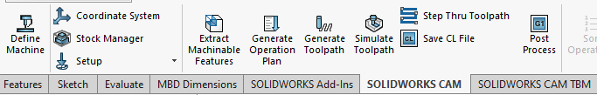

Click on Define Machine:

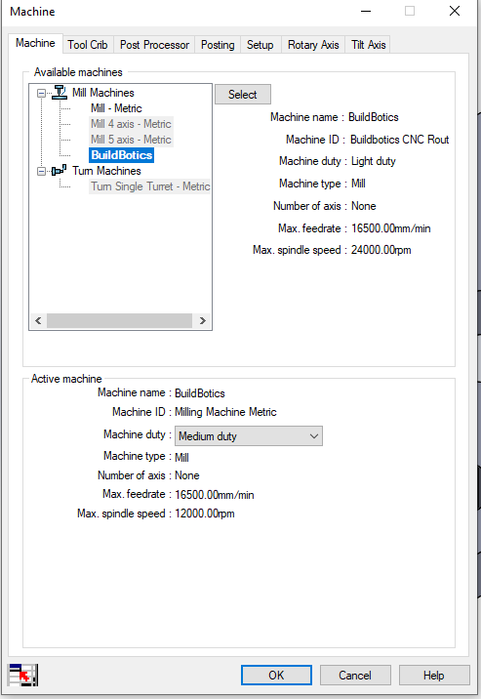

Ensure that Buildbotics is the selected mill machine, and double check that it also appears in the active machine section.

Navigate over to the Post Processor tab and ensure that the SW_BUILDBOTICS_POST.ctl post processor is selected. Then click Select to be certain.

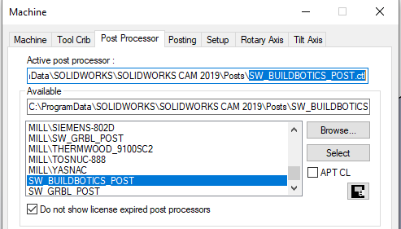

Now it’s time to select the material properties and set the axes coordinates.

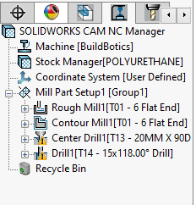

Start by clicking on Stock Manager, and then selecting POLYURETHANE as a material, it’s the closest available to the foam we will be cutting. Accept the change by selecting the ✔ icon. You then need to setup the Coordinate System as this is what determines where the cnc will start cutting from. A recommended location is the front left corner of the foam. Accept it by clicking the check mark again.

You are now set to begin generating the gCode.



In sequence, click on Extract Machinable Features, then Generate Operation Plan followed by Generate Toolpath. At this point SolidWorks will have selected the best cutting tools available in the tool library to perform each milling and drilling operation. For this sample part, you can see there is a rough mill operation followed by a contour mill to clean up the edges. Then there is a centre drill followed by a drilling cycle.



Now you can click on the Post Process button and it allows you to name the .nc file and change where it is saved.

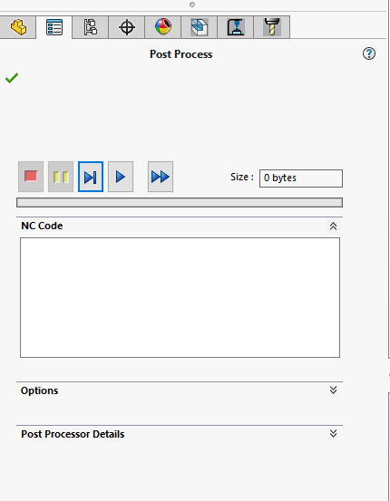

Next to generate the gCode, click the ⏩ button, this will show a loading bar, following which you can click the check mark.

Congratulations, you have created usable gCode using SolidWorks CAM!